**DAILY ONLINE ACTIVITIES SUMMARY**

|  |  |  |  |  |  |  |  |  |
| --- | --- | --- | --- | --- | --- | --- | --- | --- |
| **Date:** | **10-07-2020** | | | | | **Name:** | **Anix Jugal D’Cunha** | |
| **Sem & Sec** | **8 sem , A sec** | | | | | **USN:** | **4AL16CS013** | |
| **Online Test Summary** | | | | | | | | |
| **Subject** | | **Not Conducted** | | | | | | |
| **Max. Marks** | | **--** | | **Score** | | | **--** | |
| **Certification Course Summary** | | | | | | | | |
| **Course** | **Learn HTML5 Advanced Programming** | | | | | | | |
| **Certificate Provider** | | | **Udemy** | | **Duration** | | | 3hr 10min |
| **Coding Challenges** | | | | | | | | |
| **Problem Statement:** Java Program To Calculate Distance Between Two Points. | | | | | | | | |
| **Status: Competed** | | | | | | | | |
| **Uploaded the report in Github** | | | | | **yes** | | | |
| **If yes Repository name** | | | | | **alvas-education-foundation/dcunhaanixjugal** | | | |
| **Uploaded the report in slack** | | | | | **yes** | | | |

Online Test Details: (Attach the snapshot and briefly write the report for the same)

**Not Conducted**

Certification Course Details: (Attach the snapshot and briefly write the report for the same)

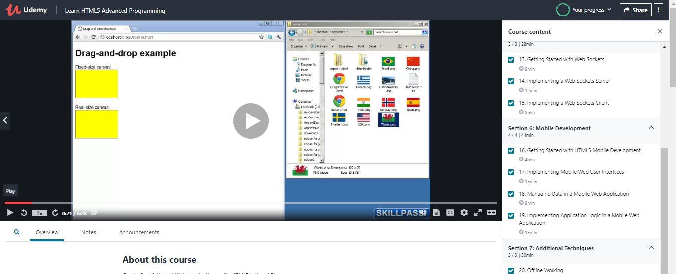

Coding Challenges Details: (Attach the snapshot and briefly write the report for the same)

## Program-> Java Program To Calculate Distance Between Two Points.

|  |
| --- |
|  |

**class DistanceBwPoint**

**{**

**public static void main(String arg[])**

**{**

**int x1,x2,y1,y2;**

**double dis;**

**x1=1;y1=1;x2=4;y2=4;**

**dis=Math.sqrt((x2-x1)*(x2-x1) + (y2-y1)*(y2-y1));**

**System.out.println("distancebetween"+"("+x1+","+y1+"),"+"("+x2+","+y2+")===>"+dis);**

**}**

**}**

**output:**

**distancebetween(1,1),(4,4)===>4.242640687119285**